**Task 1 – Write a program to swap two number. For example a=10 and b=20 output should be a=20 and b=10**

**Program:**

**package** Assignment1;

**public** **class** Task1 {

**public** **static** **void** main(String[] args) {

//Write a program to swap two number. For example a=10 and b=20 output should be a=20 and b=10

**int** a=10;

**int** b=20;

System.***out***.println("Value of a and b before swapping: "+a + " " + b);

**int** temp=a; //a value is stored in temp variable

a=b;

b=temp;

System.***out***.println("Value of a and b after swapping: "+a + " " + b);

}

}

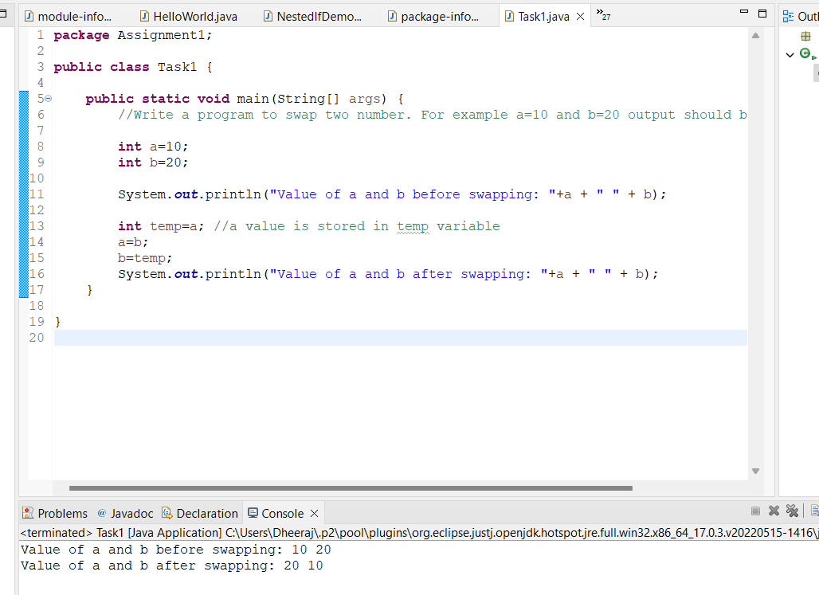

**Task 2- Write a program to print the sum of below 5 numbers.**

**10,90.78,111,8989,7876**

Solution:

**package** Assignment1;

**public** **class** Task2b {

**public** **static** **void** main(String[] args) {

// storing number in an array of double type

**double**[] add= {10,90.78,111,8989,7876};

**double** sum=0;

**for** (**int** i=0;i<5;i++)

{

sum=sum+add[i];

}

System.***out***.println(sum);

}

}

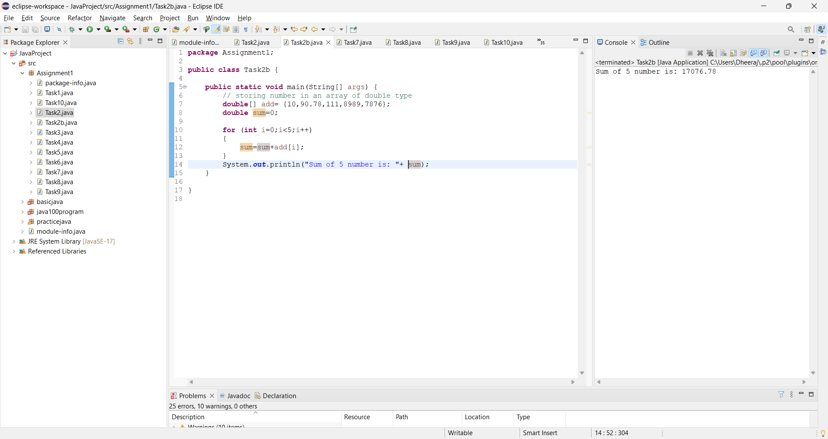

**Task 3- Write a program to print the average of below 5 numbers.**

**10,90.78,111,8989,7876**

Program:

**package** Assignment1;

**public** **class** Task3 {

**public** **static** **void** main(String[] args) {

// storing number in an array of double type

**double**[] add= {10,90.78,111,8989,7876};

**double** avg=0;

**for** (**int** i=0;i<5;i++)

{

avg=(avg+add[i])/5;

}

System.***out***.println("Average of 5 Number is: "+ avg);

}

}

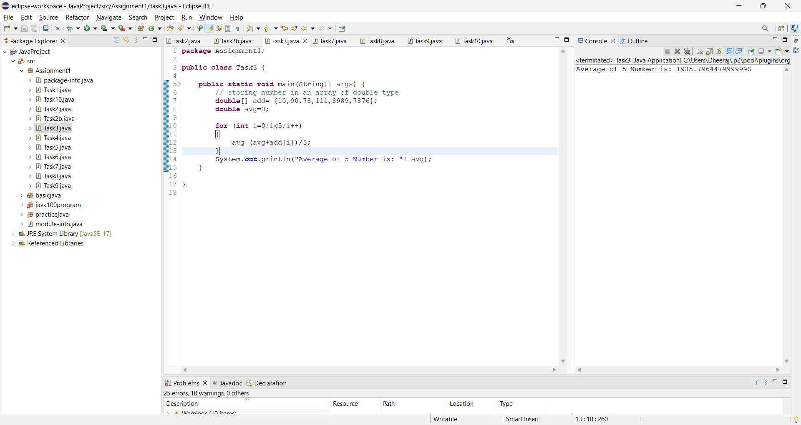

**Task 4- Write a program to print all even numbers from 1-200**

Program:

**package** Assignment1;

**public** **class** Task4 {

**public** **static** **void** main(String[] args) {

System.***out***.println("Even numbers from 1-200:");

**for**(**int** i=2;i<201;i++)

{

**if** (i%2==0)

{

System.***out***.println(i+" ");

}

}

}

}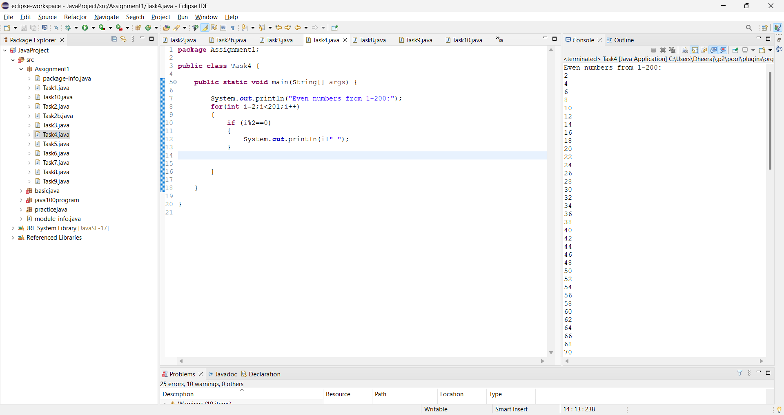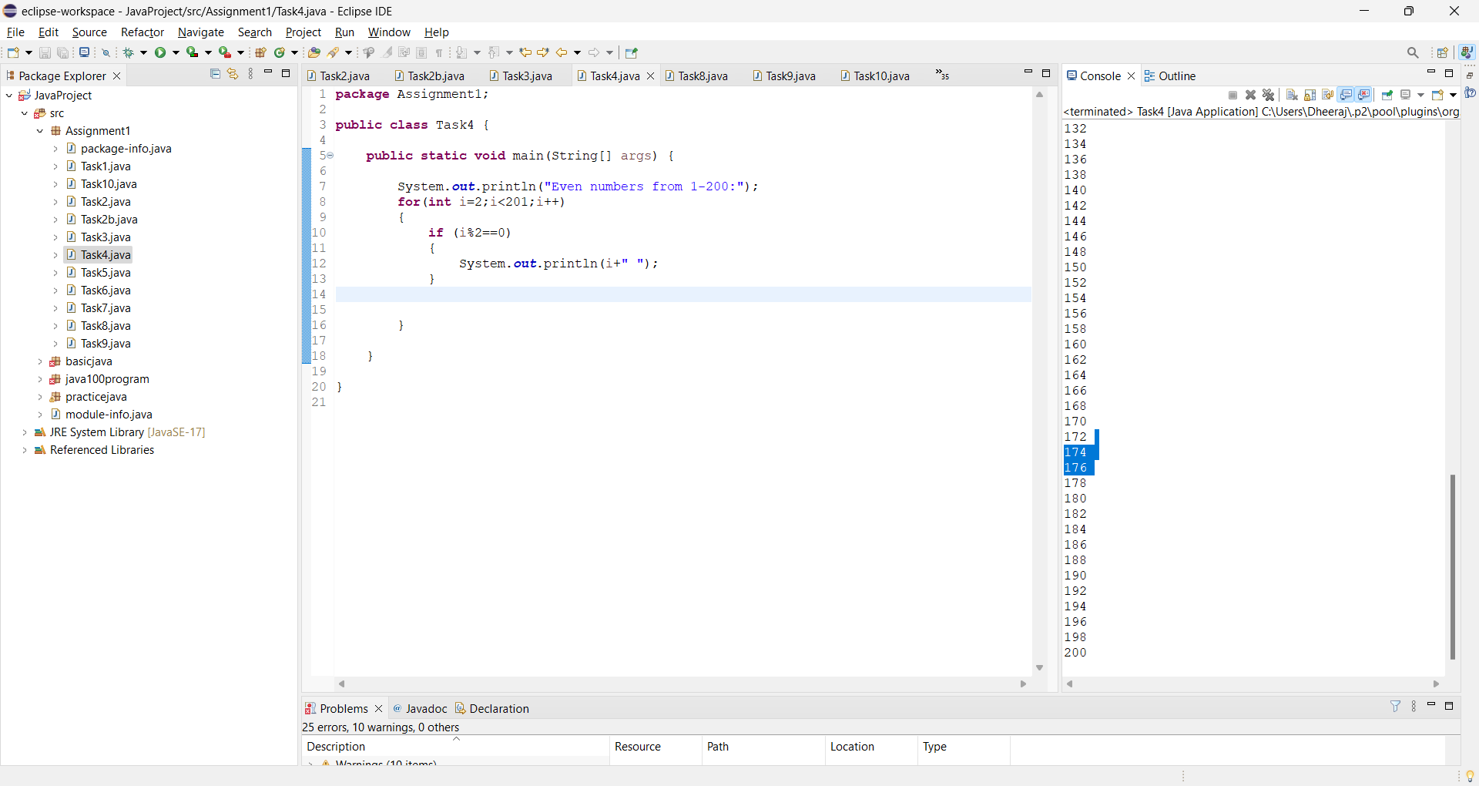

**Task 5- Write a program to print all odd numbers from 1-50**

**Program:**

**package** Assignment1;

**public** **class** Task5 {

**public** **static** **void** main(String[] args) {

System.***out***.println("odd numbers from 1-50:");

**for** (**int** i=1;i<51;i++)

{

**if**(i%2!=0)

{

System.***out***.println(i);

}

}

}

}

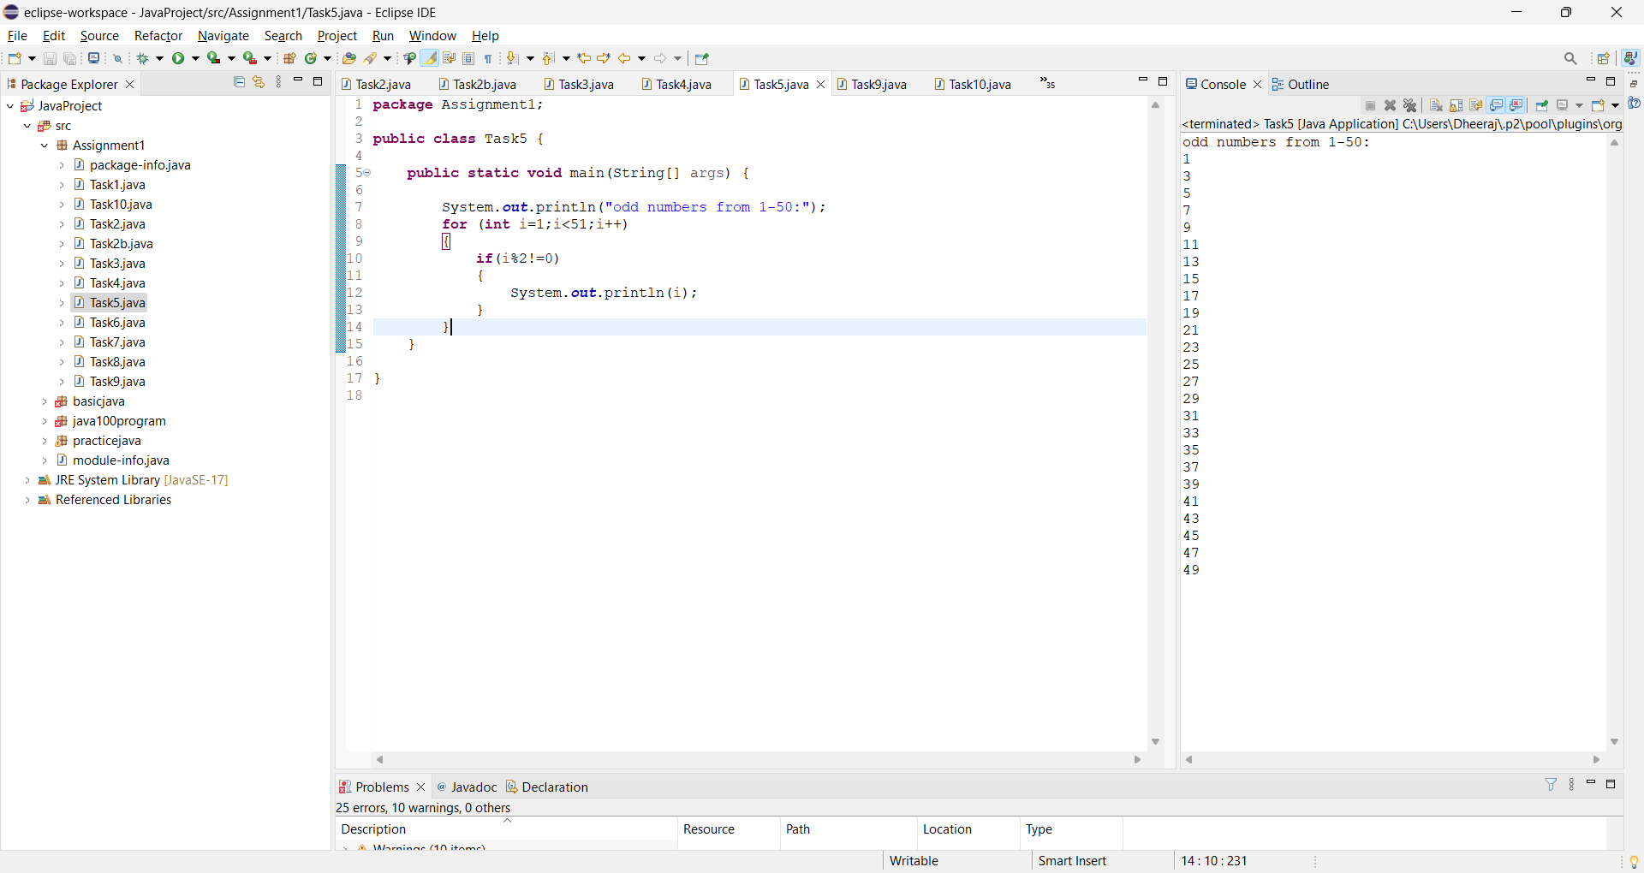

**Task 6- Write a program to print all prime numbers from 1-1000**

**Program:**

**package** Assignment1;

**public** **class** Task6 {

**public** **static** **void** main(String[] args) {

**for** (**int** i = 2; i <1001; i++) {

**boolean** prime = **true**;

**for** (**int** j = 2; j <= Math.*sqrt*(i); j++) {

**if** (i % j == 0) {

prime = **false**;

**break**;

}

}

**if** (prime) {

System.***out***.println(i);

}

}

}

}

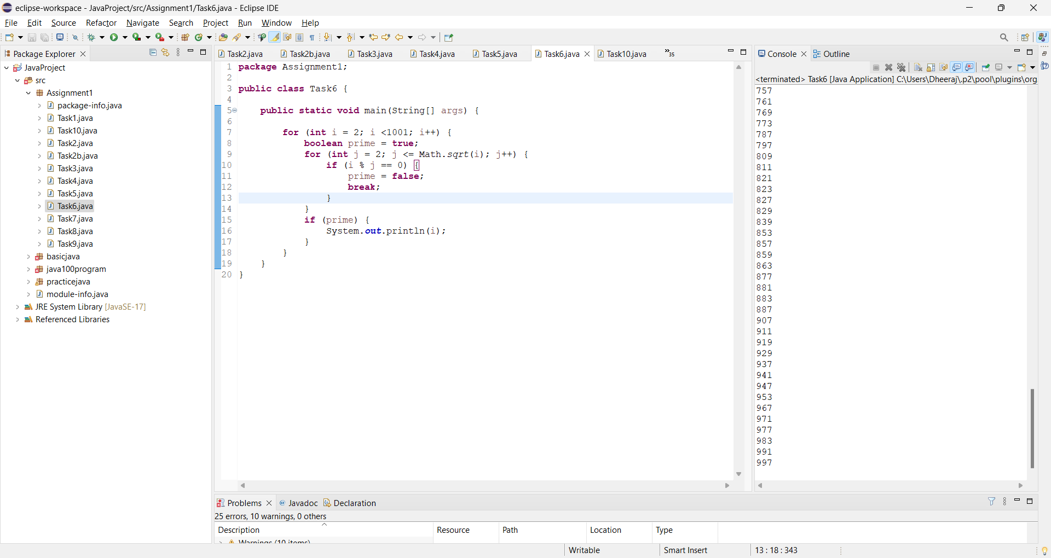

**Task 7- Write a program to print below pattern**

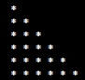

**package** Assignment1;

**public** **class** Task7 {

**public** **static** **void** main(String[] args) {

// a is Total number of row

**int** i,j,a=6;

**for** (i=0;i<a;i++)

{

**for** (j=0;j<=i;j++)

{

System.***out***.print("*");

}

System.***out***.println();

}

}

}

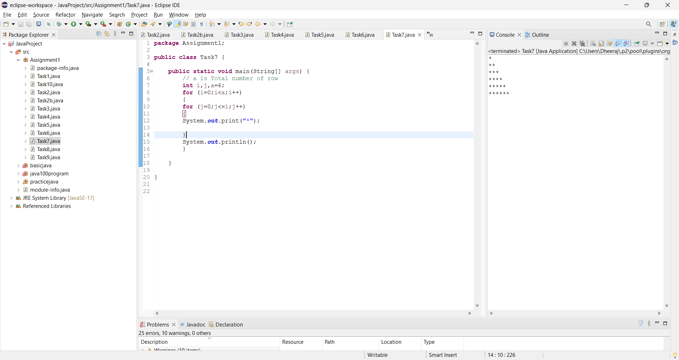

**Task 8- Write a program to print below students marks who have scored above 80**

**Example- 78,12,89,55,35**

**Output- 78,89**

Program:

**package** Assignment1;

**public** **class** Task8 {

**public** **static** **void** main(String[] args) {

// 78,12,89,55,35

**int**[] marks= {78,12,89,55,35};

**for**(**int** i=0;i<5;i++)

{

**if**(marks[i]>80)

{

System.***out***.println("Student who has scored more than 80 is:"+marks[i]);

}

}

}

}

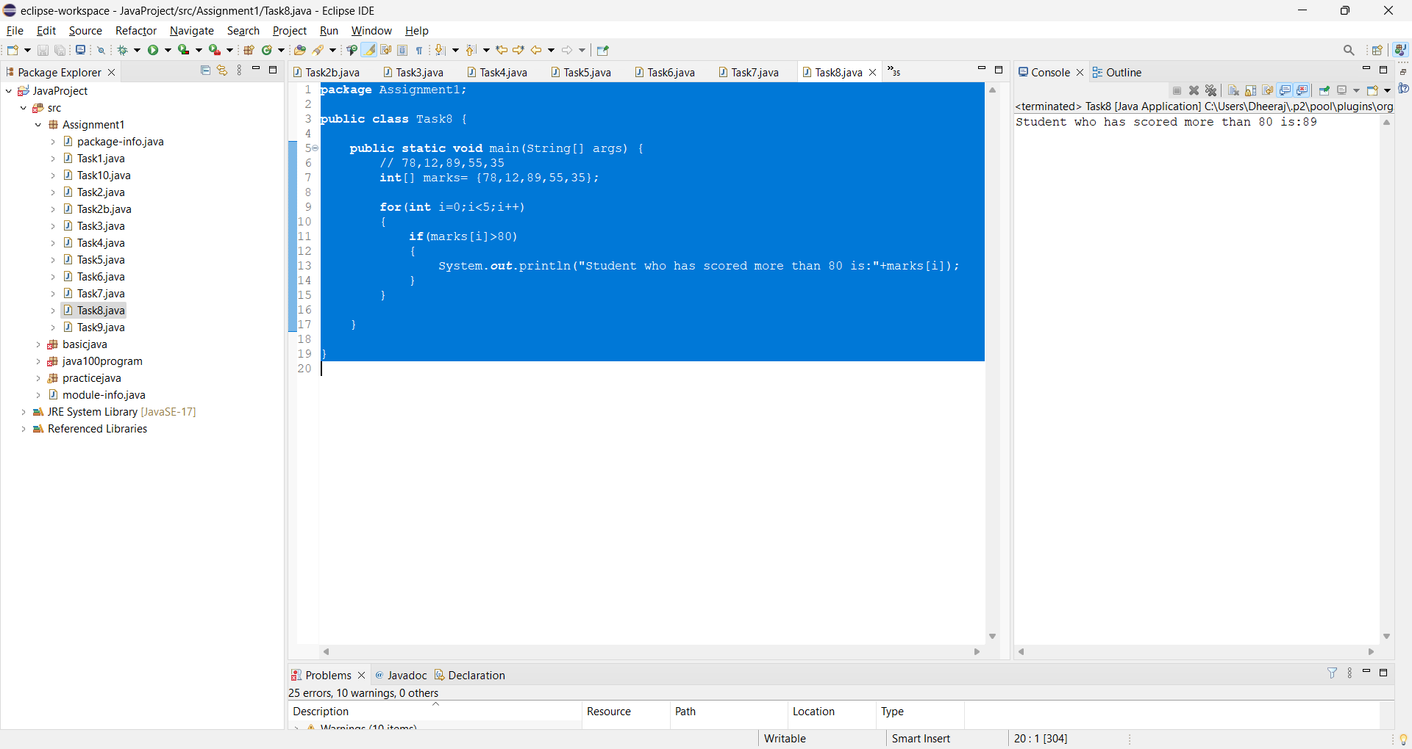

**Task 9- Write a program which will break the current execution if it find number 85**

**Input – [12,34,66,85,900]**

Program:

**package** Assignment1;

**public** **class** Task9 {

**public** **static** **void** main(String[] args) {

// 12,34,66,85,900

**int**[] number= {12,34,66,85,900};

**for** (**int** i=0;i<5;i++)

{

**if**(number[i]==85)

{

System.***out***.println("Execution stopped at 85");

**break**;

}

System.***out***.println(number[i]);

}

}

}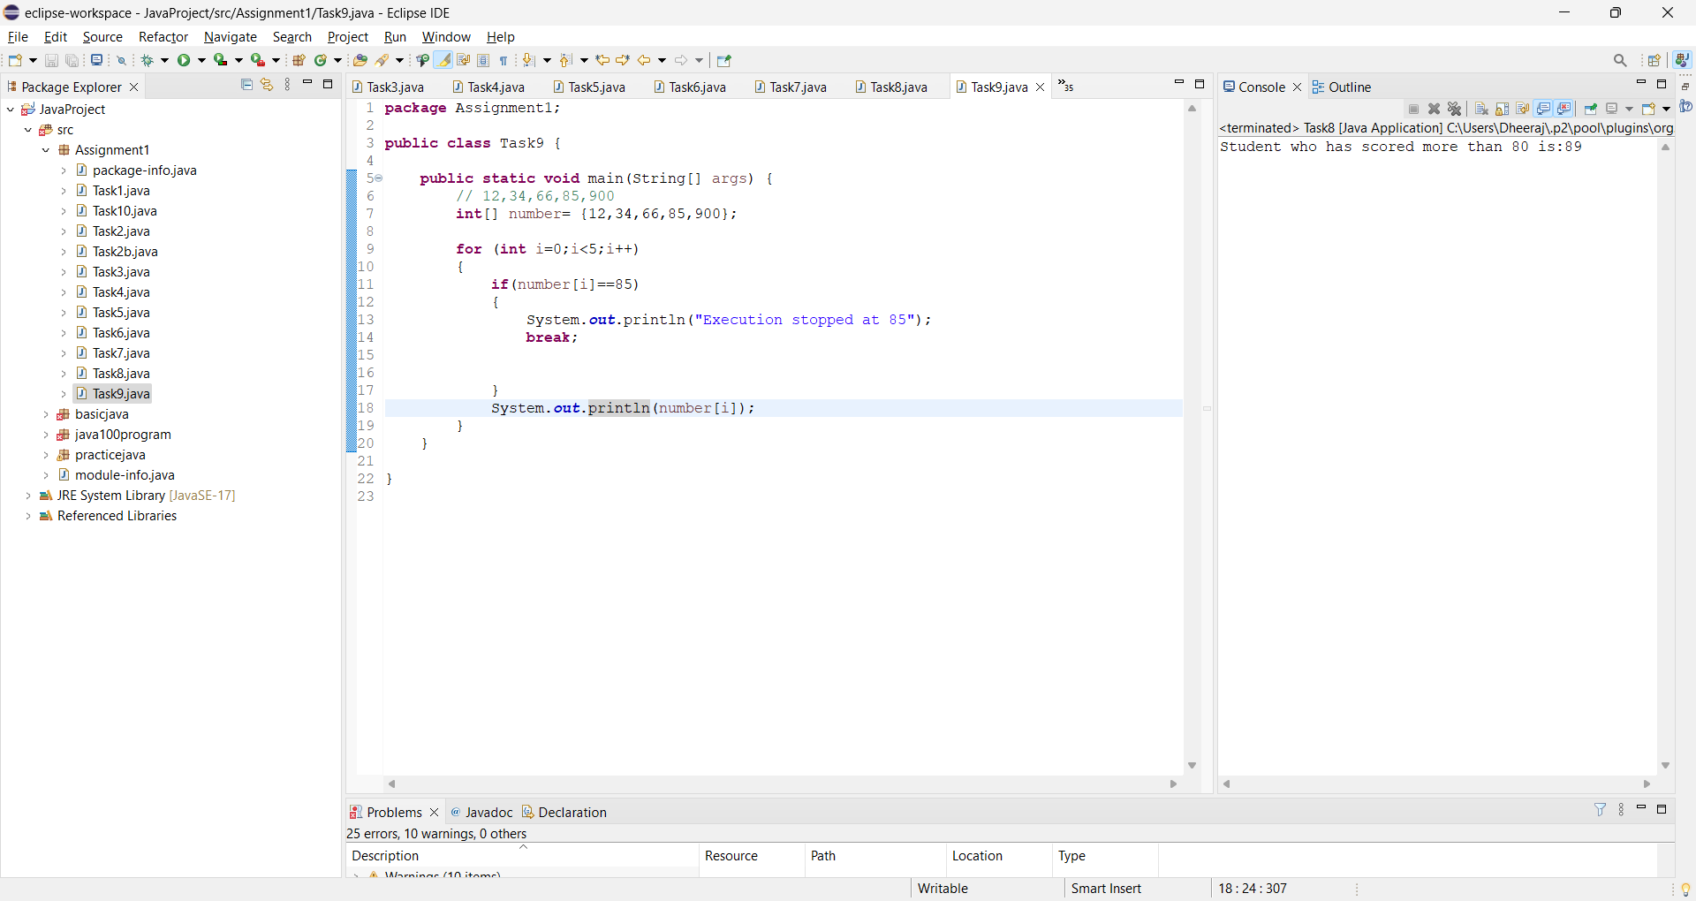

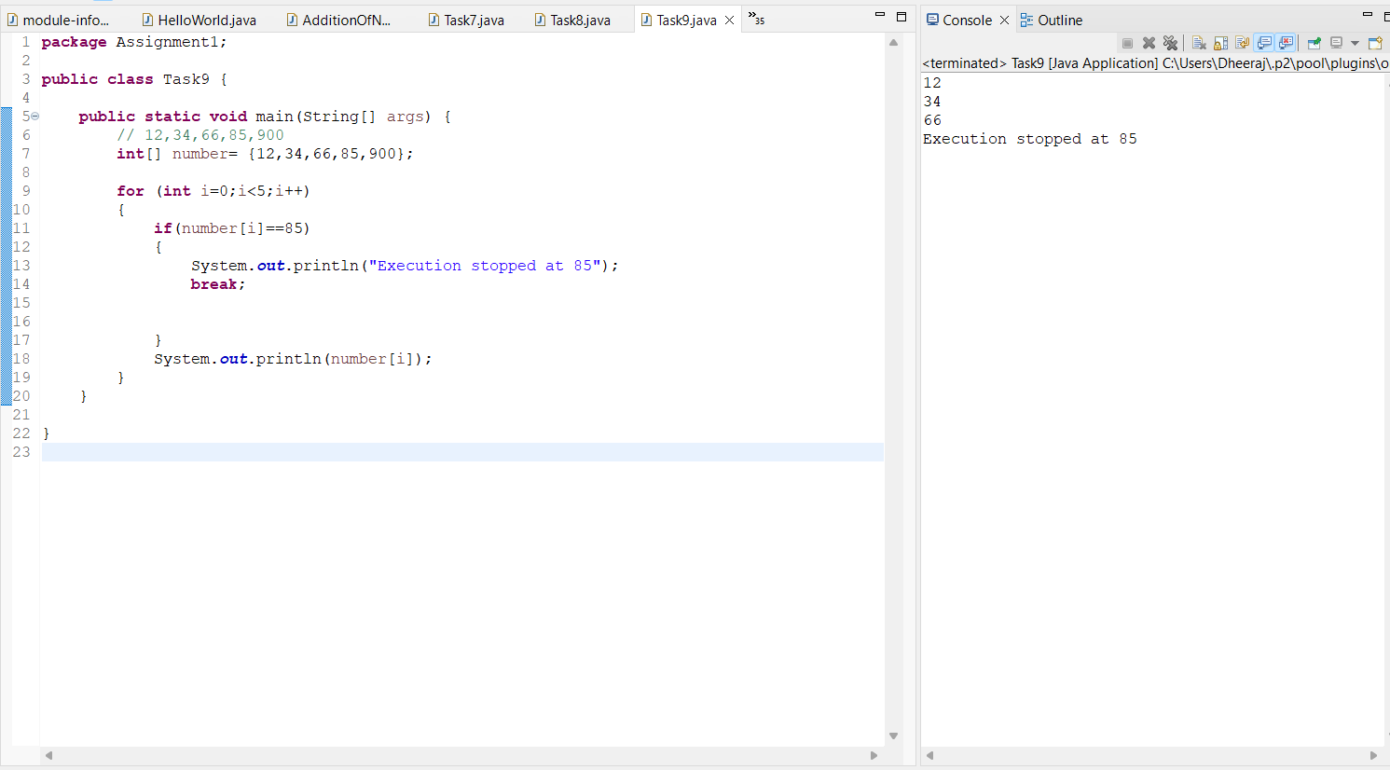

**Task 10- Write a program which will break the current execution if it find “Selenium”**

**Input – [“Java”,”JavaScript”,”Selenium”,”Python”,”Mukesh”]**

Program:

**package** Assignment1;

**public** **class** Task10 {

**public** **static** **void** main(String[] args) {

// “Java”,”JavaScript”,”Selenium”,”Python”,”Mukesh”

String[] input= {"Java","JavaScript","Selenium","Python","Mukesh"};

**for** (**int** i=0;i<5;i++)

{

**if**(input[i]=="Selenium")

{

System.***out***.println("Execution stopped at Selenium");

**break**;

}

System.***out***.println(input[i]);

}

}

}

